Edge Computing
Edge computing is a distributed information technology (IT) architecture in which client data is processed at the periphery of the network, as close to the originating source as possible . Edge computing is a distributed computing paradigm that brings computation and data storage closer to the sources of data. This is expected to improve response times and save bandwidth. "A common misconception is that edge and IoT are synonymous. Edge computing is a topology- and location-sensitive form of distributed computing, while IoT is a use case instantiation of edge computing. The term refers to an architecture rather than a specific technology.
The origins of edge computing lie in content delivery networks that were created in the late 1990s to serve web and video content from edge servers that were deployed close to users. In the early 2000s, these networks evolved to host applications and application components at the edge servers, resulting in the first commercial edge computing services that hosted applications such as dealer locators, shopping carts, real-time data aggregators, and ad insertion engines.
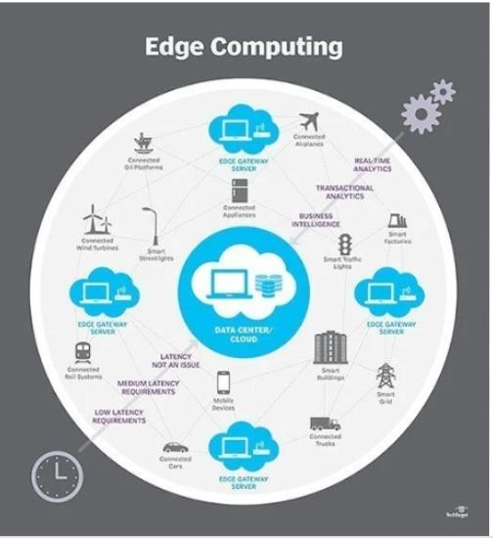
Concept
The world’s data is expected to grow 61% to 175 zettabytes by 2025. The increase of IoT devices at the edge of the network is producing a massive amount of data – storing and using all that data in cloud data centers pushes network bandwidth requirements to the limit. Despite the improvements of network technology, data centers cannot guarantee acceptable transfer rates and response times, which, however, often is a critical requirement for many applications. Furthermore, devices at the edge constantly consume data coming from the cloud, forcing companies to decentralize data storage and service provisioning, leveraging physical proximity to the end user.
In a similar way, the aim of edge computing is to move the computation away from data centers towards the edge of the network, exploiting smart objects, mobile phones, or network gateways to perform tasks and provide services on behalf of the cloud.[16] By moving services to the edge, it is possible to provide content caching, service delivery, persistent data storage, and IoT management resulting in better response times and transfer rates. At the same time, distributing the logic to different network nodes introduces new issues and challenges.

Privacy and security
The distributed nature of this paradigm introduces a shift in security schemes used in cloud computing. In edge computing, data may travel between different distributed nodes connected through the Internet and thus requires special encryption mechanisms independent of the cloud. Edge nodes may also be resource-constrained devices, limiting the choice in terms of security methods. Moreover, a shift from centralized top-down infrastructure to a decentralized trust model is required. On the other hand, by keeping and processing data at the edge, it is possible to increase privacy by minimizing the transmission of sensitive information to the cloud. Furthermore, the ownership of collected data shifts from service providers to end-users.

Scalability
Scalability in a distributed network must face different issues. First, it must take into account the heterogeneity of the devices, having different performance and energy constraints, the highly dynamic condition, and the reliability of the connections compared to more robust infrastructure of cloud data centers. Moreover, security requirements may introduce further latency in the communication between nodes, which may slow down the scaling process.

Reliability
Management of failovers is crucial in order to keep a service alive. If a single node goes down and is unreachable, users should still be able to access a service without interruptions. Moreover, edge computing systems must provide actions to recover from a failure and alerting the user about the incident. To this aim, each device must maintain the network topology of the entire distributed system, so that detection of errors and recovery become easily applicable. Other factors that may influence this aspect are the connection technologies in use, which may provide different levels of reliability, and the accuracy of the data produced at the edge that could be unreliable due to particular environment conditions. As an example an edge computing device, such as a voice assistant may continue to provide service to local users even during cloud service or internet outages.

Speed
Edge computing brings analytical computational resources close to the end users and therefore can increase the responsiveness and throughput of applications. A well-designed edge platform would significantly outperform a traditional cloud-based system. Some applications rely on short response times, making edge computing a significantly more feasible option than cloud computing. Examples range from IoT to autonomous driving, anything health or human / public safety relevant, or involving human perception such as facial recognition, which typically takes a human between 370-620ms to perform. Edge computing is more likely to be able to mimic the same perception speed as humans, which is useful in applications such as augmented reality where the headset should preferably recognize who a person is at the same time as the wearer does.

Efficiency
Due to the nearness of the analytical resources to the end users, sophisticated analytical tools and Artificial Intelligence tools can run on the edge of the system. This placement at the edge helps to increase operational efficiency and is responsible for many advantages to the system.
Additionally, the usage of edge computing as an intermediate stage between client devices and the wider internet results in efficiency savings that can be demonstrated in the following example: A client device requires computationally intensive processing on video files to be performed on external servers. By using servers located on a local edge network to perform those computations, the video files only need to be transmitted in the local network. Avoiding transmission over the internet results in significant bandwidth savings and therefore increases efficiency. Another example is voice recognition. If the recognition is performed locally, it is possible to send the recognized text to the cloud rather than audio recordings, significantly reducing the amount of required bandwidth.

How does edge computing works ?
Edge computing is all a matter of location. In traditional enterprise computing, data is produced at a client endpoint, such as a user's computer. That data is moved across a WAN such as the internet, through the corporate LAN, where the data is stored and worked upon by an enterprise application. Results of that work are then conveyed back to the client endpoint. This remains a proven and time-tested approach to client-server computing for most typical business applications.
But the number of devices connected to the internet, and the volume of data being produced by those devices and used by businesses, is growing far too quickly for traditional data center infrastructures to accommodate. by 2025, 75% of enterprise-generated data will be created outside of centralized data centers. The prospect of moving so much data in situations that can often be time- or disruption-sensitive puts incredible strain on the global internet, which itself is often subject to congestion and disruption.
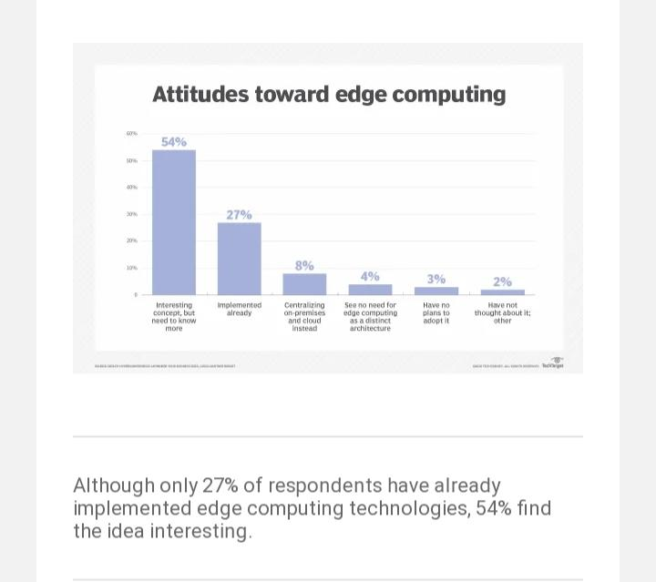
So IT architects have shifted focus from the central data center to the logical edge of the infrastructure -- taking storage and computing resources from the data center and moving those resources to the point where the data is generated. The principle is straightforward: If you can't get the data closer to the data center, get the data center closer to the data. The concept of edge computing isn't new, and it is rooted in decades-old ideas of remote computing -- such as remote offices and branch offices -- where it was more reliable and efficient to place computing resources at the desired location rather than rely on a single central location.

Edge computing puts storage and servers where the data is, often requiring little more than a partial rack of gear to operate on the remote LAN to collect and process the data locally. In many cases, the computing gear is deployed in shielded or hardened enclosures to protect the gear from extremes of temperature, moisture and other environmental conditions. Processing often involves normalizing and analyzing the data stream to look for business intelligence, and only the results of the analysis are sent back to the principal data center.
The idea of business intelligence can vary dramatically. Some examples include retail environments where video surveillance of the showroom floor might be combined with actual sales data to determine the most desirable product configuration or consumer demand. Other examples involve predictive analytics that can guide equipment maintenance and repair before actual defects or failures occur. Still other examples are often aligned with utilities, such as water treatment or electricity generation, to ensure that equipment is functioning properly and to maintain the quality of output.

